Assignment 2: 159.339

Brent Dykgraaf – 00037354

October 2013

Sweets Emporium

Application use

The application provides a home page from where a user can login / register, or begin to browse the categories. A user can also search the products from any screen by typing into the search box. The user can see the number of items in their shopping cart at all times in the menu header. Clicking on this will take them to a detailed view of the shopping cart contents

Clicking on a category takes the user to a display of all of the products in the particular category. If the user searches they get a similar page but with the found items from any of the categories. On the category page a user can select a product to buy and enter their required quantity. They can also click on the item for more information. This takes them to the products page.

The products page displays the details of a single item and also a larger photo. The user can order the item from this page.

A user can login to the application by selecting the login link at the top right hand side of the page. This takes them to the login screen which requires a username and password. Once logged in the user can click My Details to view their details, edit their details or see a history of previous transactions. A logged in user can also click on my cart to display the contents of the shopping cart, from the shopping cart screen they can place an order.

If the user is not registered the link beside login provides a method to register on the website. Once registered the user can click login to use the application.

Database design

The database is a simple 5 table design. A shopping cart is simply a pending order, this saves the need for another table to track these details. When an order is placed the shopping cart has its status changed from pending to ordered.

The table diagram below shows all of the tables and their relationships to each other.

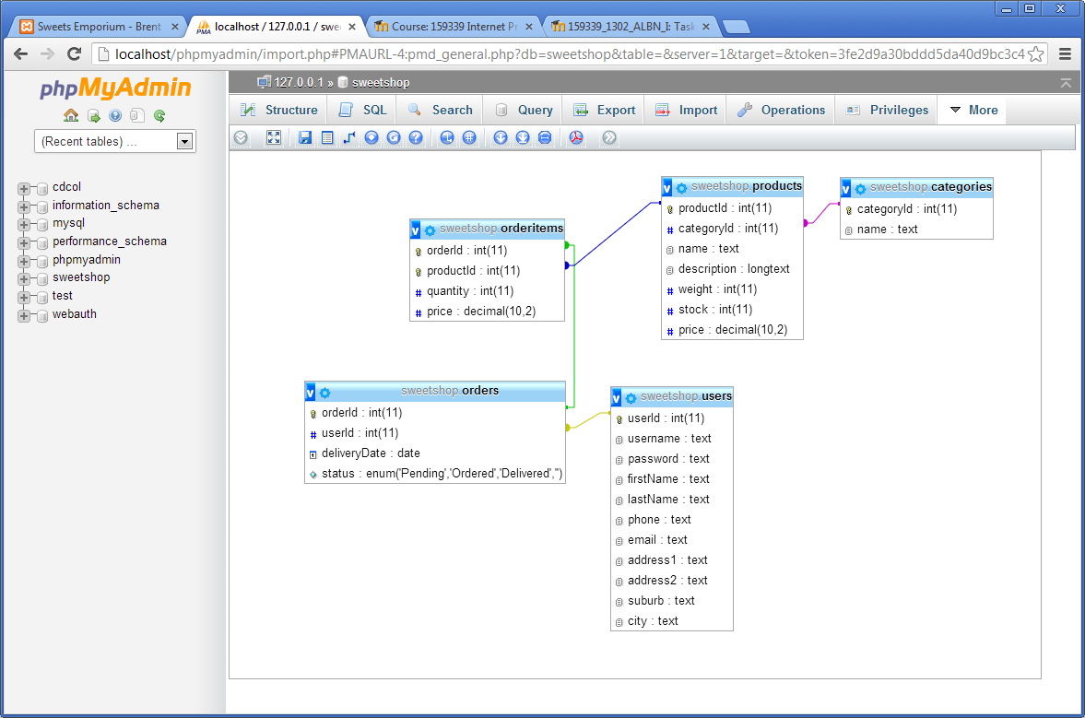

Application Design

The application is accessed through a single page index.php in the root directory. This file receives the details of the desired page to view through the “s” parameter passed as a get request in the URL.

The application separates out the display, application logic and business logic into separate tiers.

* **Layout:** The layout and display is controlled by the Layout object and the template system. When a page is requested the Layout object receives the name of the required screen through $viewData[“screen”]. The layout renders the header, adds the template file of the same name, and then adds the footer. The Layout can also be set by the page controller to return information to an AJAX query, in this case it does not add the header and footer information. Each template screen has been tested at the w3.org HTML validator to ensure it has no errors
* **Application Logic:** The application logic is controlled by startup.php and pageController.php. startup.php loads all the classes, gets the current user and shopping cart and also deals with all user data submitted into the application through get and post requests (including filtering). pageController.php sets the appropriate page for the Layout to display. It also prepares any data required for the Layout and processes any actions required. All data used by the Layout is passed from the pageController in the $viewData array. This helps ensure abstraction between the two layers.
* **Business Logic:** The business logic for the shop is contained in a series of classes such as user, category, product and order. These objects are each responsible for the database access functions as well.

Diagram of the classes

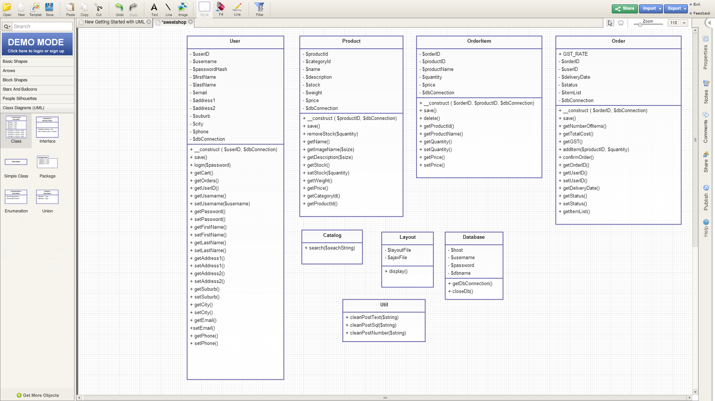

The file structure of the application is

* /application/data – This contains the SQL import file to establish the database
* /application/includes – Contains startup.php and pageController.php
* /application/src – Contains all of the PHP classes for the application
* /application/templates/ajax – templates for generating individual AJAX responses
* /application/templates/layout – Header, Footer and main layout tempaltes
* /application/templates/pages – templates for each page
* /public/js – Javascript files
* /public/css – CSS files
* /public/img – Image files, including for the catalog
* index.php

**Security**

* Only the index.php file can be accessed from the web, all other files have access restricted by .htaccess.
* Input is validated on the user side to ensure correct. On the server side the response is filtered to ensure only valid characters can be submitted.
* All input in SQL queries from user data is escaped